**TEST DATA/Documentation**

The login screen



Fill out with credentials (will return with “Please fill out fields” if left empty)

Successful login will lead to welcome page to make appointment

Unsuccessful login will redirect back to login page



Welcome page to make appointment where you fill in data and select a day and time slot

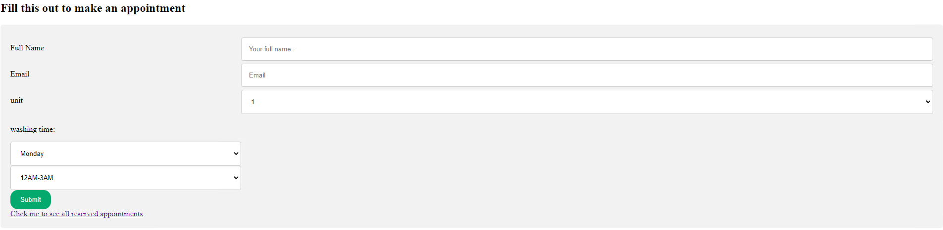

User can also check the already made appointments by pressing the link under submit to check what’s available and what’s not available

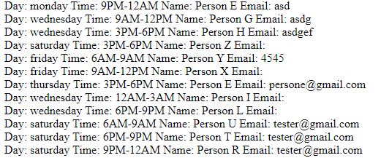

After filling in the info click on submit

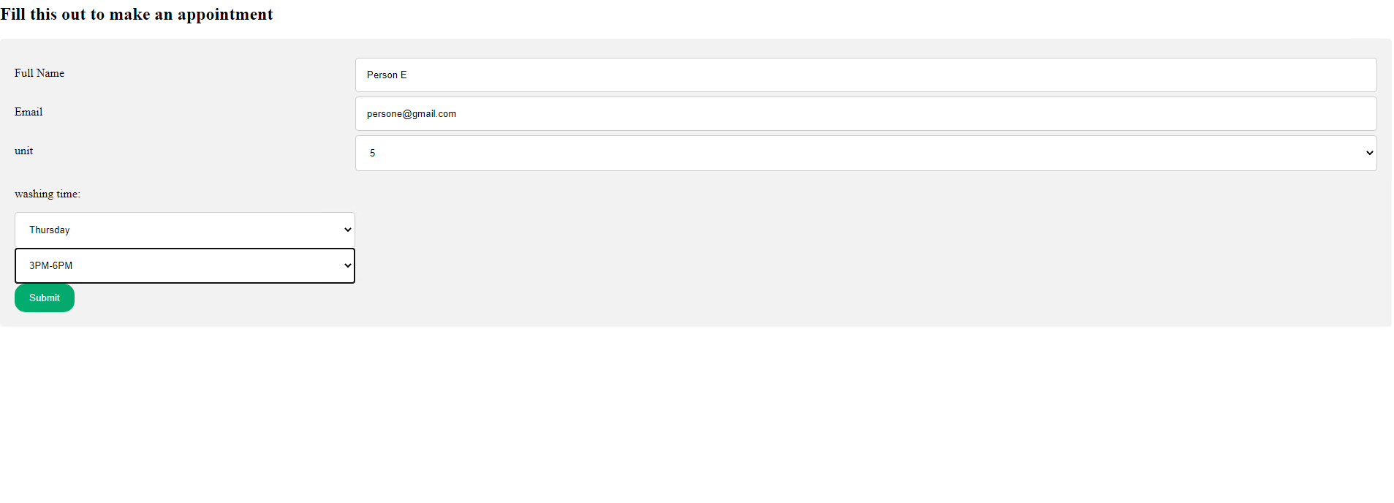

If there is no appointments for that day and time slot in database, the appointment will be successfully made



If there was already an appointment made for that day and time slot, an error will be returned.



If the user has already made an appointment, an error will be returned.

